

**SRN: PES1UG20CS415**

**Name: SHRUJAN**

**Section: G**

**Date: 15/9/2021**

**Q1)** 1. Implement the following operations on singly linked list (5 + 5Marks) (ii) Swap 2 nodes without swapping the data. (iii) Delete every alternate node starting from the first node

**Code:**

#*include*<stdio.h>

#*include*<stdlib.h>

struct node

{

        int data;

        struct node* next;

};

void *insert*(struct node **p,int n);

void *display*(struct node **p);

void *swap*(struct node **p);

void *deletealt*(struct node **p);

int *main*()

{

        int n,v;

        struct node* p;

        p=NULL;

  A:

*printf*("Enter Your Choice\n1.Add Element\n2.Swap Nodes\n3.Delete Alternate Nodes\n0.Exit\n");

*scanf*("%d",&n);

*switch*(n)

        {

*case* 1:*printf*("Enter Value to be inserted \n");

*scanf*("%d",&v);

*insert*(&p,v);

*display*(&p);

*break*;

*case* 2: *swap*(&p);

*printf*("\n\nSwapped Successfully\n");

*display*(&p);

*break*;

*case* 3: *deletealt*(&p);

*printf*("\n\nDeleted Successfully\n");

*display*(&p);

*break*;

*case* 0: *exit*(0);

        }

*goto* A;

*return* 0;

}

void *insert*(struct node **p,int n)

{

*if*(*p==NULL)

        {

                *p=(struct node*)*malloc*(sizeof(struct node));

                (*p)->data=n;

                (*p)->next=NULL;

        }

*else*

        {

                struct node *temp;

                temp=(struct node*)*malloc*(sizeof(struct node));

                temp ->data =n ;

                temp->next=(*p);

                (*p)=temp;

        }

}

void *display*(struct node **p)

{

        struct node *temp;

        temp = *p;

*while*(temp !=NULL)

        {

*printf*("%d -> ",temp->data);

                temp=temp->next;

        }

}

void *swap*(struct node **p)

{

        struct node *pres;

        struct node *next2;

        pres=*p;

        next2 = pres->next;

*while*(next2->next !=NULL)

        {

                next2 = next2->next;

                pres = pres->next;

        }

        next2->next = (*p);

        pres->next = NULL;

        (*p)=next2;

}

void *deletealt*(struct node **p)

{

        struct node *pres;

        struct node *next2;

        struct node *temp;

        pres = *p;

        next2 = pres->next;

        temp=pres;

*while*(next2 !=NULL && temp !=NULL)

        {

                temp->next= next2->next;

                temp=temp->next;

                next2=temp->next;

        }

        *p=pres;

}

**Output :**

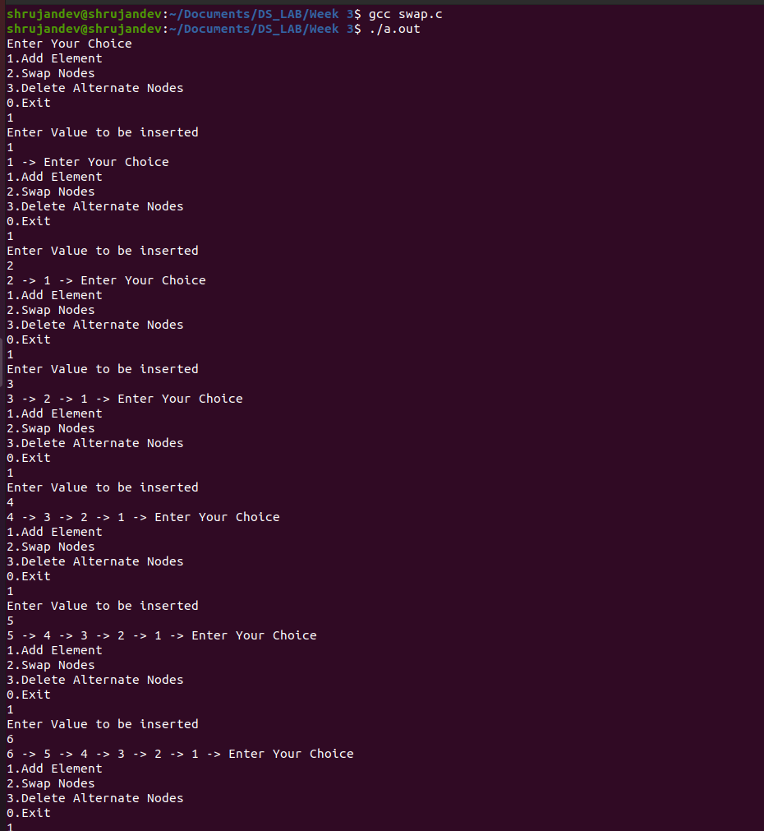

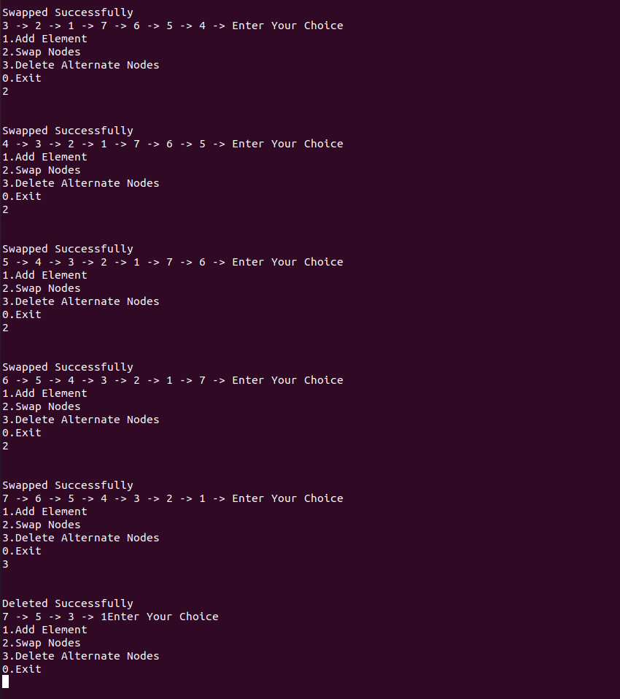

**Q2)** Perform the addition of 2 polynomials stored as a Singly linked list.

**Code:** #*include*<stdio.h>

#*include*<stdlib.h>

struct node

{

        int coeff;

        int px;

        int py;

        struct node* next;

};

void *insert*(struct node **p,int c,int x,int y);

void *display*(struct node **p);

void *calculate*(struct node **f,struct node **s);

int *main*()

{

        int n,v;

        struct node* f;

        struct node* s;

        f=NULL;

        s=NULL;

        int c,x,y;

A:

*printf*("\n\nEnter Your Choice\n1.Instert to first Polynomial\n2.Insert to Second Polynomial\n3.Calculate \n0.Exit\n");

*scanf*("%d",&n);

*switch*(n)

        {

*case* 1:*printf*("Enter Coeffecient \n");

*scanf*("%d",&c);

*printf*("Enter power of x \n");

*scanf*("%d",&x);

*printf*("Enter power of y \n");

*scanf*("%d",&y);

*insert*(&f,c,x,y);

*printf*("\nFirst Polynomial\n");

*display*(&f);

*break*;

*case* 2:*printf*("Enter Coeffecient \n");

*scanf*("%d",&c);

*printf*("Enter power of x \n");

*scanf*("%d",&x);

*printf*("Enter power of y \n");

*scanf*("%d",&y);

*insert*(&s,c,x,y);

*printf*("\nSecond Polynomial\n");

*display*(&s);

*break*;

*case* 3: *calculate*(&f,&s);

*break*;

*case* 0: *exit*(0);

        }

*goto* A;

*return* 0;

}

void *insert*(struct node **p,int c,int x,int y)

{

*if*(*p==NULL)

        {

                *p=(struct node*)*malloc*(sizeof(struct node));

                (*p)->coeff=c;

                (*p)->px=x;

                (*p)->py=y;

                (*p)->next=NULL;

        }

*else*

        {

                struct node *temp;

                temp=(struct node*)*malloc*(sizeof(struct node));

                temp->coeff=c;

                temp->px=x;

                temp->py=y;

                temp->next=(*p);

                (*p)=temp;

        }

}

void *display*(struct node **p)

{

        struct node *temp;

        temp = *p;

*while*(temp !=NULL)

        {

*printf*("%dx^%dy^%d +",temp->coeff,temp->px,temp->py);

                temp=temp->next;

        }

}

void *calculate*(struct node **f,struct node **s)

{

        struct node *ft;

        struct node *st;

        ft = *f;

        st = *s;

*while*(ft!=NULL)

        {

*while*(st!=NULL)

                {

*if*((st->px==ft->px) && (st->py==ft->py))

                        {

                                int r;

                                r= (st->coeff) + (ft->coeff);

*printf*(" \n\n%dx^%dy^%d +",r,st->px,st->py);

                        }

                        st=st->next;

                }

                ft=ft->next;

        }

}

**Output:**

